# Consider the following Django models:

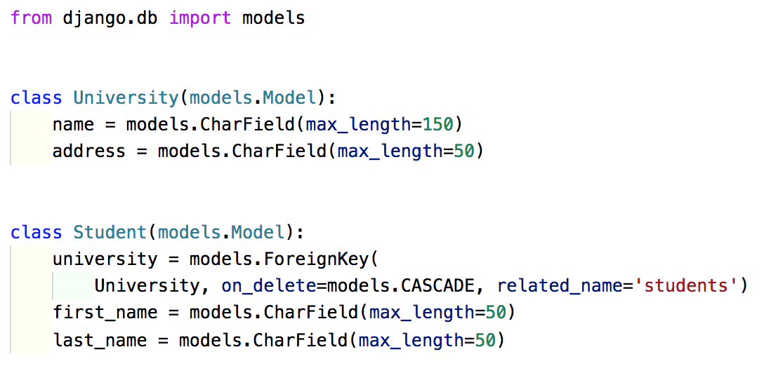

* 1. How do you read a University named “University of Otago” from the database?
  2. Print all students from “University of Otago” (first and last name).

# Write a test case for the following class:

